**From:** Agnes, Chong   
**Sent:** Wednesday, 15 February, 2017 6:07 PM  
**To:** Chan, Pei-Fong  
**Subject:** Revise Form F-LOG-BD-38

Hi Pei Fong,

Below changes as per BD’ s request.

Kindly revise and send me the blank form.

Thank you.

.      Form F-LOG-BD-38, please proceed to remove the highlighted section and send a copy of the updated form to me.

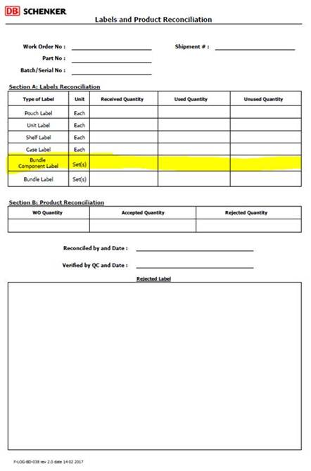

Best Regards,

Agnes Chong

Senior Executive

Contract Logistic/SCM

Schenker Singapore (Pte) Ltd  
5 Tuas View Lane, Singapore 637291

DID: +65 6861 8907 Mobile +65 8138 6732

Visit us @ [www.dbschenker.com](http://www.dbschenker.com/)

[ Please consider the impact to the Environment before printing this email ]